Troy Prujean - 9930285

COMP.5210 | assignment one – Part a

Design Brief



**Contents**

1.1 Site Outline 2

1.2 Sitemap 3

1.3 Important files 4

**robots.txt** 4

**sitemap.xml** 5

1.4 Pages 6

**index.HTML (homepage)** 6

Wireframe 6

Design Specifications 7

**about.HTML** 8

Wireframe 8

Design Specifications 9

**services.HTML** 10

Wireframe 10

Design Specifications 11

**gallery.HTML** 12

Wireframe 12

Design Specifications 13

**contact.HTML** 14

Wireframe 14

Design Specifications 15

References 16

# 1.1 Site Outline

The features of the design are simple, yet effective for its purpose. Kayla’s Cleaning Services is a small, family operated business with a pre-existing client base. The need for extensive marketing is unnecessary as the company is often running at full capacity without any advertising. The implementation of a simple, straight forward design showing a small portfolio, service details, company and contact information will be effective for its purpose.

The site will contain a total of 5 pages, home, about, cleaning services, gallery and contact. Each page will have the same header, footer and navigation bar to ensure the user becomes familiar with the interface and can navigate effectively.

* **Home** page will be a simple landing page with a hero image and relevant quote showing, small icons showing different service types.
* **About** page will include background information about the company.
* **Cleaning Services** page will include information of the services the company has to offer.
* **Gallery** page will be a portfolio gallery showing before and after photos of the more significant work the company has completed.
* **Contact** page will contain a form with relevant fields for the user to fill out and submit a message / request to the companies email inbox. The page will also contain alternative contact details for the company.

A large amount of Kayla’s customers are real estate agents who are primarily mobile and away from their desk. For this reason, a major requirement for the site is to keep it responsive by using meta tags to auto adjust element sizes so that the pages are easily viewable and maintain their interactivity on any size screen.

# 1.2 Sitemap

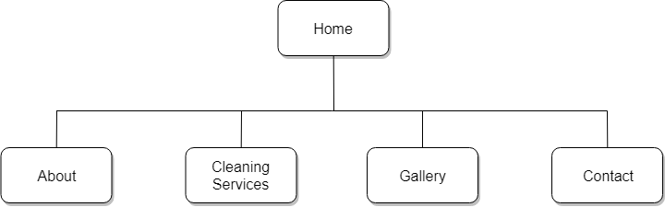

# 1.3 Important files

There are other important components of modern websites, such as; sitemap.xml and robots.txt. Every website that is interested in getting as many visitors as possible should include these files. For this assignment the files will **not** be included (robots.txt and sitemap files, n.d.).

## **robots.txt**

robots.txtis a simple.txt file which has a primary purpose of restricting access to your site from search engine robots or “bots”. The file can be opened or created in almost any notepad, HTML editor or word processor. The file needs to be in the root directory of the site, this is important as all the main search engine spiders will automatically look for the file in this directory to take instructions before crawling your site (Creare, 2011).

An example of a robots.txt file content is:

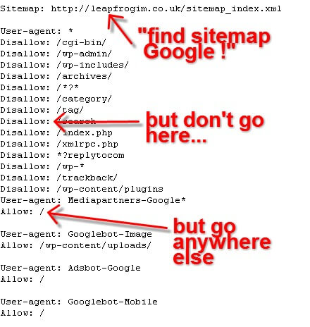

(Roy, 2013)

## **sitemap.xml**

There are two different types of sitemaps, there are XML site maps and HTML sitemaps. XML sitemaps are created for search engines and help them point to pages on your site, this helps ensure that pages aren’t missed or overlooked by crawlers. HTML sitemaps are displayed on the site and easily read and understood by users. They can be used for the user to know exactly where they are within the structure of the site, they can be clicked on to navigate back through prior directories of the page they are currently browsing.

An XML sitemap is intended to be read by search engine robots, it includes behind the scenes activities and provides additional information about the site. It can include information such as; when the page was last updated, how often the page changes and how important the page is in relation to other pages on your site. This information allows search engine robots to analyse the content on your site more logically. An XML sitemap is especially useful for new sites that have not yet been discovered by search engines. By uploading your sitemap to google search console and other systems you are able to inform search engines of the presence of your new site and what pages exist (May, n.d.).

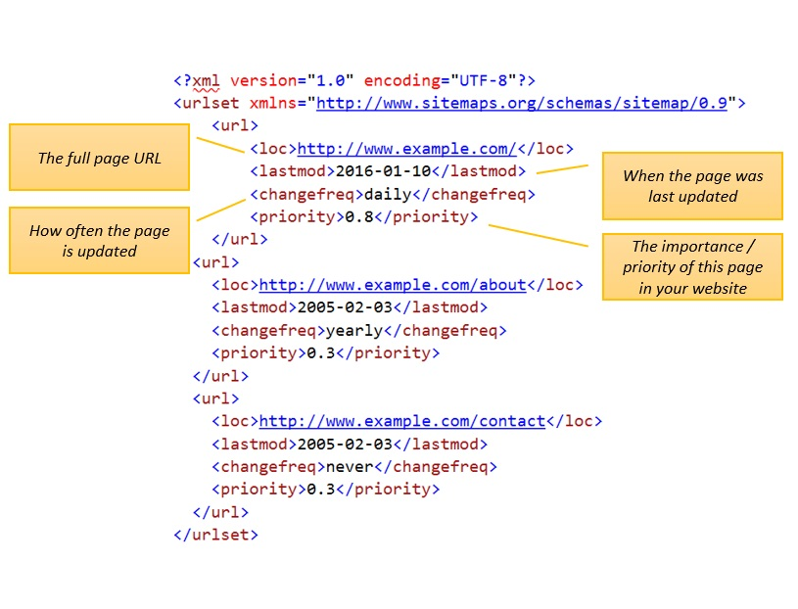An example of a sitemap.xml file content is:

(XML Sitemap Example, 2016)

# 1.4 Pages

## **index.HTML (homepage)**

### **Wireframe**

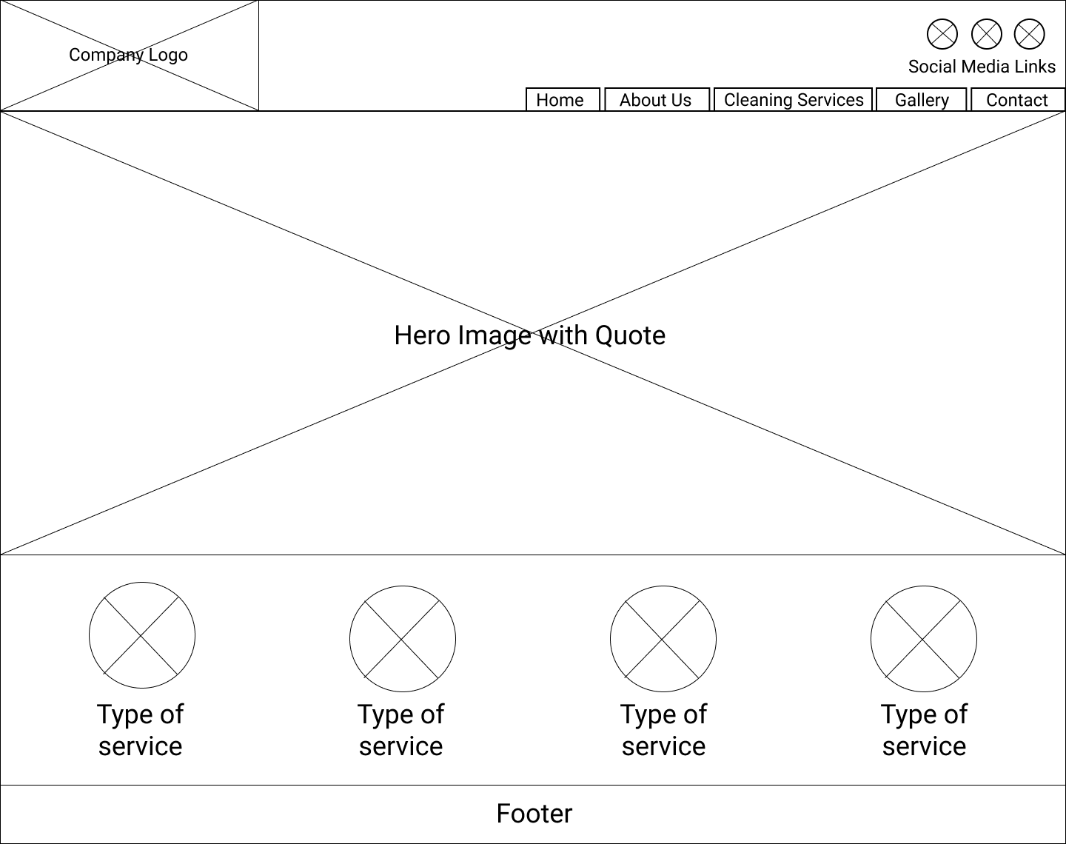

### **Design Specifications**

**Header**

**Colours:** Background:white

**Image(s):** Company logo – top left (Width: 271px, Height: 200px)

**Element size:** Width: 1 fraction of grid (responsive), Height: 200px

**Navbar**

**Font family:** Arial, Helvetica, sans-serif

**Font weight:** Bold

**Font colour:** White

**Font size:** 16px

**Colours:** Background:dark slate blue - #3B4476

**Element size:** Width: 3 fractions of grid (responsive), Height: 40px

**Social Media Icons**

**Colours:**

Facebook Background:dark blue - #3B5998

Instagram Background: dark blue - #125688

Twitter Background: light blue - #55ACEE

**Image(s):** Font awesome icon images - Width: 50px, Height: 56px (all three the same)

**Element size:** Width: 50px, Height: 56px (all three the same)

**Hero Image**

**Font family:** Arial, Helvetica, sans-serif

**Font weight:** Normal

**Font colour:** Dark slate blue - #3B4476

**Font size:** 50px

**Button font colour:** White

**Button font size:** 16px

**Button background colour:** Dark slate blue - #3B4476

**Image(s):** hero image of cleaning tools (width: auto (responsive), height: 700px)

**Element size:** auto (responsive) x 700px

**Icon Images & Text**

**Font family:** Arial, Helvetica, sans-serif

**Font weight:** Normal

**Font colour:** Dark slate blue - #3B4476

**Font size:** 24px

**Image(s):** Icon images of cleaning types (width:240px, height:240px (all 4 the same))

**Element size:** Width: 1 fraction of grid (responsive), height:400px (all 4 the same)

**Footer**

**Font family:** Arial, Helvetica, sans-serif

**Font weight:** Normal

**Font colour:** White

**Font size:** 16px

**Colour:** Background:Dark slate blue - #3B4476

**Element size:** Width: auto (responsive), height: 40px

## **about.HTML**

### **Wireframe**

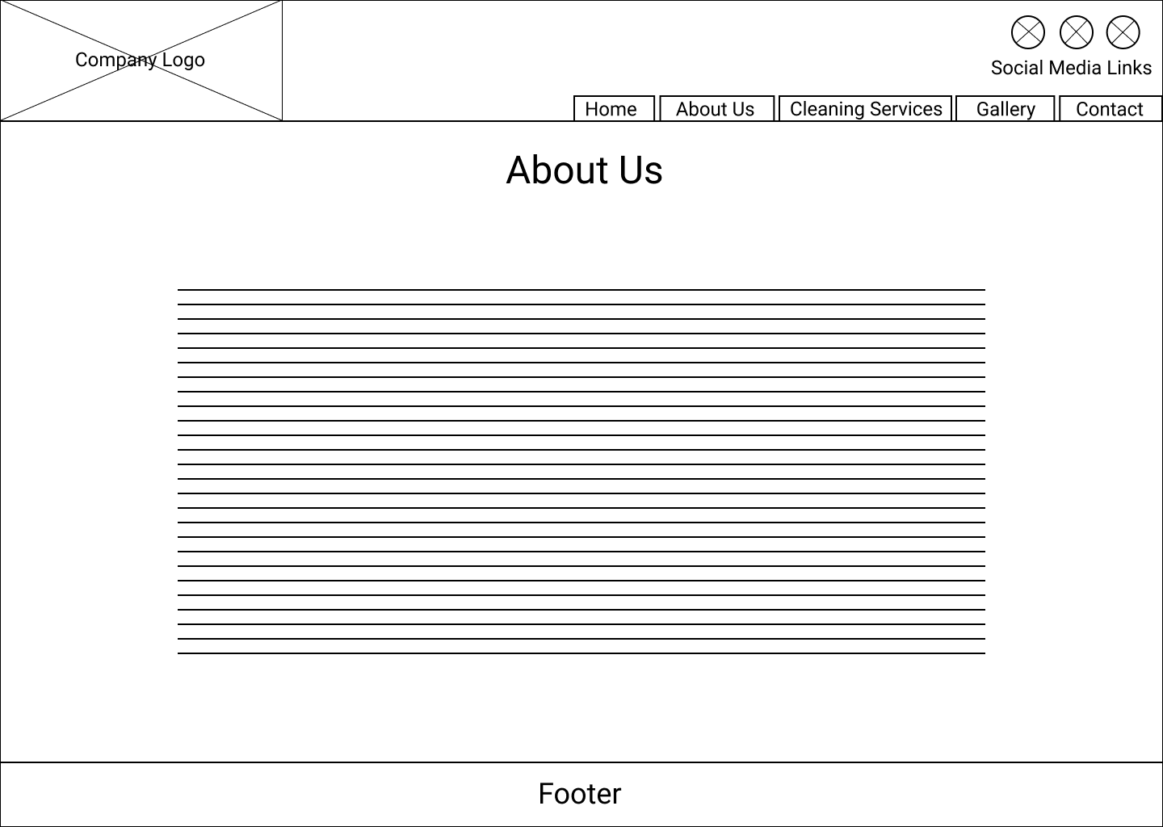

### **Design Specifications**

**Header**

**Colours:** Background:white

**Image(s):** Company logo – top left (Width: 271px, Height: 200px)

**Element size:** Width: 1 fraction of grid (responsive), Height: 200px

**Navbar**

**Font family:** Arial, Helvetica, sans-serif

**Font weight:** Bold

**Font colour:** White

**Font size:** 16px

**Colours:** Background:dark slate blue - #3B4476

**Element size:** Width: 3 fractions of grid (responsive), Height: 40px

**Social Media Icons**

**Colours:**

Facebook Background:dark blue - #3B5998

Instagram Background: dark blue - #125688

Twitter Background: light blue - #55ACEE

**Image(s):** Font awesome icon images - Width: 50px, Height: 56px (all three the same)

**Element size:** Width: 50px, Height: 56px (all three the same)

**Heading**

**Font family:** Arial, Helvetica, sans-serif

**Font weight:** Normal

**Font colour:** Dark slate blue - #3B4476

**Font size:** 40px

**Element size:** Width: auto (responsive), height: 100px

**Article / Paragraph**

**Font family:** Arial, Helvetica, sans-serif

**Font weight:** Normal

**Font colour:** black

**Font size:** 16px

**Text alignment:** Centre

**Element size:** Width: auto (responsive), height: auto (responsive)

**Footer**

**Font family:** Arial, Helvetica, sans-serif

**Font weight:** Normal

**Font colour:** White

**Font size:** 16px

**Colour:** Background:Dark slate blue - #3B4476

**Element size:** Width: auto (responsive), height: 40px

## **services.HTML**

### **Wireframe**

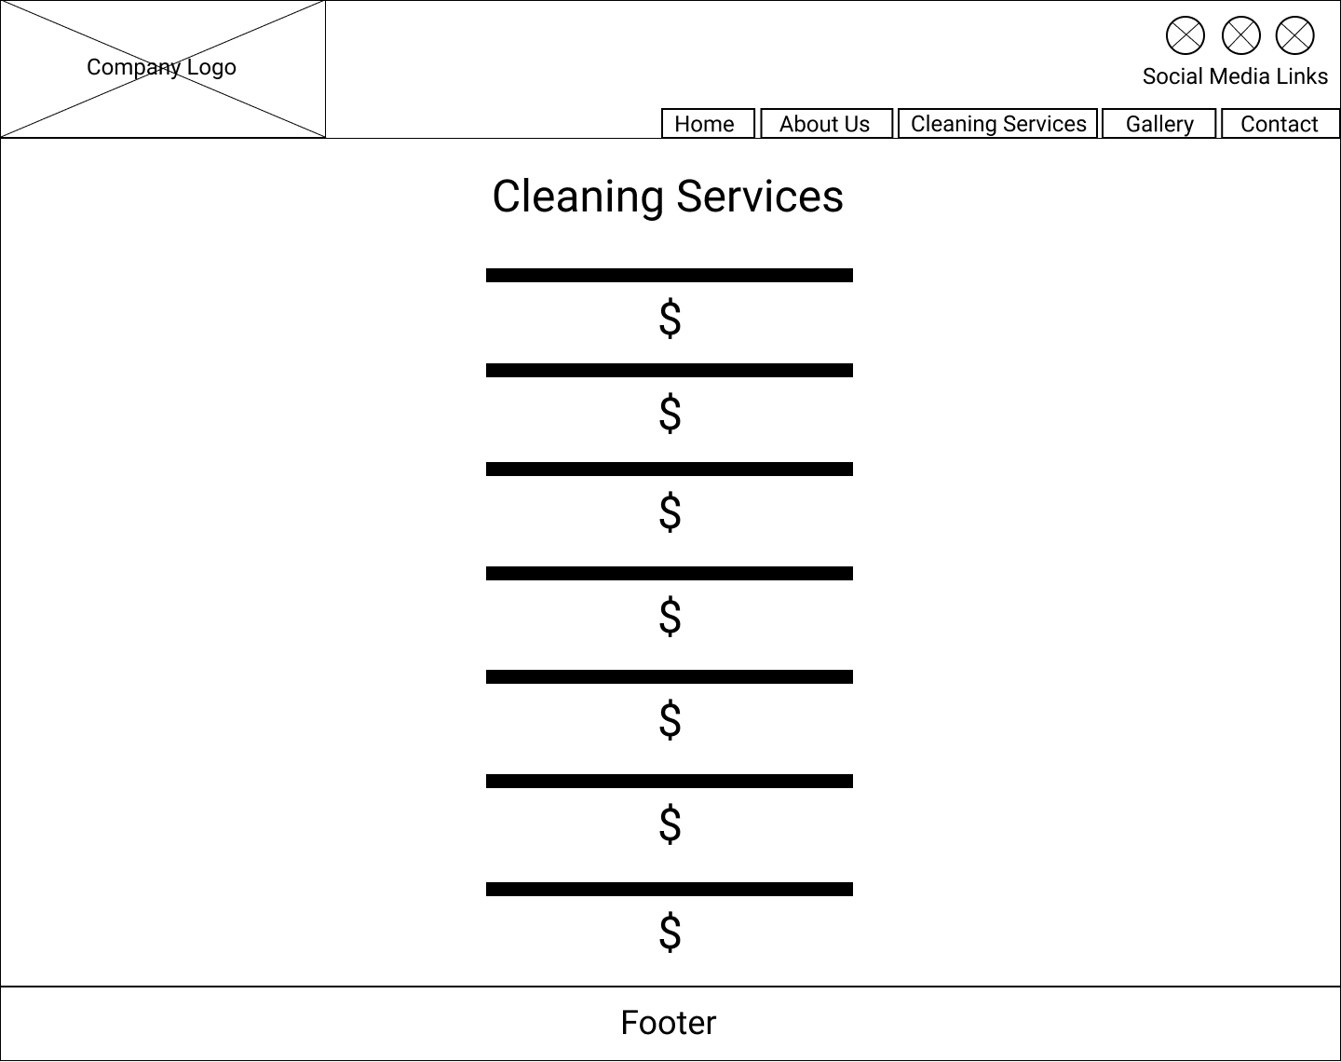

### **Design Specifications**

**Header**

**Colours:** Background:white

**Image(s):** Company logo – top left (Width: 271px, Height: 200px)

**Element size:** Width: 1 fraction of grid (responsive), Height: 200px

**Navbar**

**Font family:** Arial, Helvetica, sans-serif

**Font weight:** Bold

**Font colour:** White

**Font size:** 16px

**Colours:** Background:dark slate blue - #3B4476

**Element size:** Width: 3 fractions of grid (responsive), Height: 40px

**Social Media Icons**

**Colours:**

Facebook Background:dark blue - #3B5998

Instagram Background: dark blue - #125688

Twitter Background: light blue - #55ACEE

**Image(s):** Font awesome icon images - Width: 50px, Height: 56px (all three the same)

**Element size:** Width: 50px, Height: 56px (all three the same)

**Heading**

**Font family:** Arial, Helvetica, sans-serif

**Font weight:** Normal

**Font colour:** Dark slate blue - #3B4476

**Font size:** 40px

**Element size:** Width: auto (responsive), height: 100px

**Article / Paragraph**

**Font family:** Arial, Helvetica, sans-serif

**Font weight:** Normal & Bold

**Font colour:** black

**Font size:** 16px

**Text alignment:** Centre

**Element size:** Width: auto (responsive), height: auto (responsive)

**Footer**

**Font family:** Arial, Helvetica, sans-serif

**Font weight:** Normal

**Font colour:** White

**Font size:** 16px

**Colour:** Background:Dark slate blue - #3B4476

**Element size:** Width: auto (responsive), height: 40px

## **gallery.HTML**

### **Wireframe**

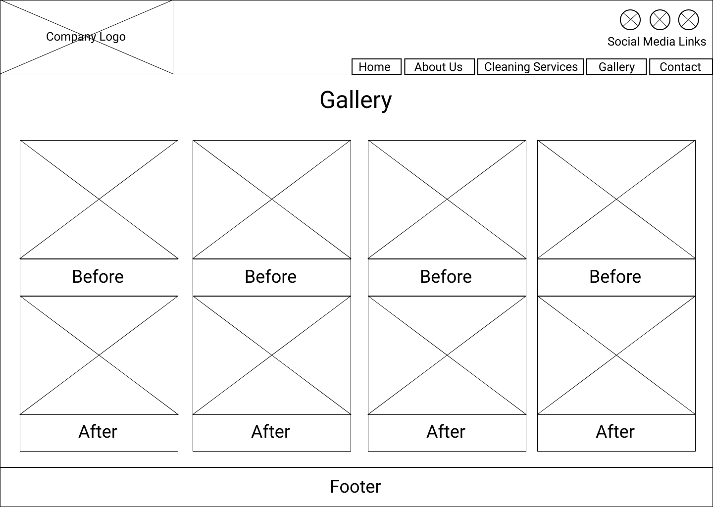

### **Design Specifications**

**Header**

**Colours:** Background:white

**Image(s):** Company logo – top left (Width: 271px, Height: 200px)

**Element size:** Width: 1 fraction of grid (responsive), Height: 200px

**Navbar**

**Font family:** Arial, Helvetica, sans-serif

**Font weight:** Bold

**Font colour:** White

**Font size:** 16px

**Colours:** Background:dark slate blue - #3B4476

**Element size:** Width: 3 fractions of grid (responsive), Height: 40px

**Social Media Icons**

**Colours:**

Facebook Background:dark blue - #3B5998

Instagram Background: dark blue - #125688

Twitter Background: light blue - #55ACEE

**Image(s):** Font awesome icon images - Width: 50px, Height: 56px (all three the same)

**Element size:** Width: 50px, Height: 56px (all three the same)

**Heading**

**Font family:** Arial, Helvetica, sans-serif

**Font weight:** Normal

**Font colour:** Dark slate blue - #3B4476

**Font size:** 40px

**Element size:** Width: auto (responsive), height: 100px

**Gallery**

**Font family:** Arial, Helvetica, sans-serif

**Font weight:** Normal & Bold

**Font colour:** black

**Font size:** 16px

**Image(s):** Before and after images - Width: 336px, Height: 252px (all eight the same)

**Element size:** Width: 1 fraction of grid (responsive), height: 700px (all four the same)

**Footer**

**Font family:** Arial, Helvetica, sans-serif

**Font weight:** Normal

**Font colour:** White

**Font size:** 16px

**Colour:** Background:Dark slate blue - #3B4476

**Element size:** Width: auto (responsive), height: 40px

## **contact.HTML**

### **Wireframe**

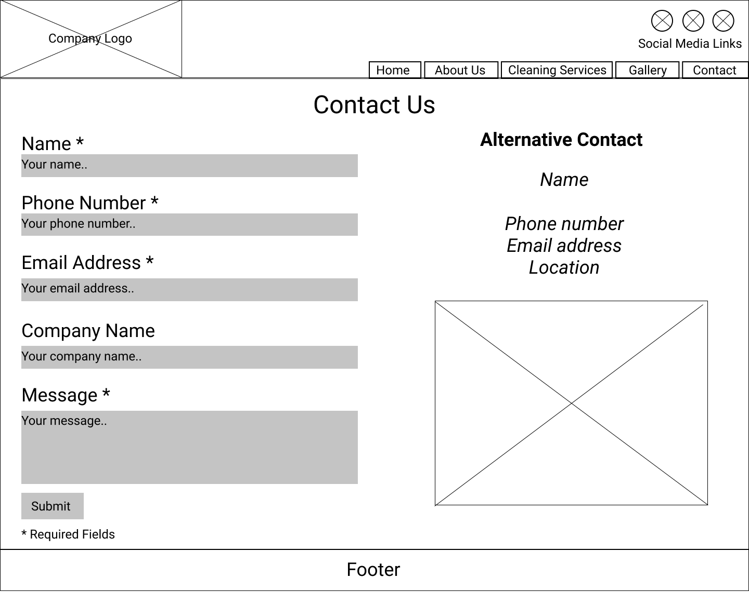

### **Design Specifications**

**Header**

**Colours:** Background:white

**Image(s):** Company logo – top left (Width: 271px, Height: 200px)

**Element size:** Width: 1 fraction of grid (responsive), Height: 200px

**Navbar**

**Font family:** Arial, Helvetica, sans-serif

**Font weight:** Bold

**Font colour:** White

**Font size:** 16px

**Colours:** Background:dark slate blue - #3B4476

**Element size:** Width: 3 fractions of grid (responsive), Height: 40px

**Social Media Icons**

**Colours:**

Facebook Background:dark blue - #3B5998

Instagram Background: dark blue - #125688

Twitter Background: light blue - #55ACEE

**Image(s):** Font awesome icon images - Width: 50px, Height: 56px (all three the same)

**Element size:** Width: 50px, Height: 56px (all three the same)

**Heading**

**Font family:** Arial, Helvetica, sans-serif

**Font weight:** Normal

**Font colour:** Dark slate blue - #3B4476

**Font size:** 40px

**Element size:** Width: auto (responsive), height: 100px

**Form**

**Font family:** Arial, Helvetica, sans-serif

**Font size:** 16px

**Label font weight:** Bold

**Label font colour:** Dark slate blue - #3B4476

**Input field font colour:** Black

**Input field size:** Width: 2 fractions of grid (responsive) with 12px of padding, height: auto

**Button font colour:** White

**Button font size:** 16px

**Button background colour:** Dark slate blue - #3B4476

**Element size:** Width: 2 fractions of grid (responsive), height: auto (responsive)

**Aside section**

**Font family:** Arial, Helvetica, sans-serif

**Font size:** 16px

**Font weight:** Normal

**Font colour:** Black

**Text alignment:** Centre

**Image(s):** Cleaning image - Width: 320px, Height: 250px

**Element size:** Width: 2 fractions of grid (responsive), height: auto (responsive)

**Footer**

**Font family:** Arial, Helvetica, sans-serif

**Font weight:** Normal

**Font colour:** White

**Font size:** 16px

**Colour:** Background:Dark slate blue - #3B4476

**Element size:** Width: auto (responsive), height: 40px

# References

Creare. (2011, November 25). *Robots.txt (Robots File) Explained - SEO Video Tutorial*. Retrieved from YouTube: https://www.youtube.com/watch?v=73RY142lb0E

May, R. (n.d.). *HTML Sitemap vs. XML Sitemap*. Retrieved from coursera: https://www.coursera.org/lecture/seo-fundamentals/html-sitemap-vs-xml-sitemap-swuHU

*robots.txt and sitemap files*. (n.d.). Retrieved from Advanced HTML: http://www.advancedhtml.co.uk/robots-sitemaps.htm

Roy, G. (2013, September 6). *Robots.txt – why your website needs this itsy-bitsy file*. Retrieved from Leap Frog: https://leapfrogim.co.uk/news/robots/

*XML Sitemap Example*. (2016, August 21). Retrieved from Xml Sitemap Generator: https://xmlsitemapgenerator.org/help/xml-sitemap-example.aspx